Research Proposal
Student profile, supervisors and Advisors |  |  |  |  |  |  |  |  | 1
1-1) Student profile
Student ID | Surname |  |  |  | First Name
1234567890 | Irandoost |  |  |  | Irandokht
Course |  |  |  |  |  |  | Degree
Operations Research |  |  |  |  |  |  | Choose an item.
Faculty
Choose an item.
1-2) Profile of Supervisors and Advisors
Affiliation | Expertise |  | Rank | Full Name |  |  |  | Responsibility
Persian Gulf University, Iran | Operations Research |  | Choose an item. | Khodakaram  Salimifard |  |  |  | Supervisor(s)
 |  |  | Choose an item.
 |  |  | Choose an item. |  |  |  |  | Advisor(s)
 |  |  | Choose an item.
1-3) Signature and date
Supervisor  Date: Click or tap to enter a date. |  | Advisor  Date: Click or tap to enter a date. |  |  |  | Student  Date: Click or tap to enter a date.
Summary |  |  |  |  |  |  |  |  | 2
2-1) Title
Type title of your research here.
2-2) Key words
First keyword, second keyword, third key word, …, up to seven keywords

2-3) Type of Research
☐ | Basic | ☐ | Applied |  | ☐ | Problem specific | ☐ | Qualitative

Research Summary | 3
3-1) Research Summary (Introduction, Statement of Problem and Importance)
3-1-1) Introduction
Here, a brief introduction to the problem is written, focusing on the history of the problem. I should be between 1 to 5 pages.
3-1-2) Statement of the Problem (SoP)
Based on the previous part, here the research problem is explained in clear, complete, and robust way. References should be used to make the argument more reliable and clearly understood.
3-1-2-1) sub-sub title
In case, you need more space to categorize your description of the problem, you may use detailed numbering with a title to go through the problem.

3-1-4) Research Problem
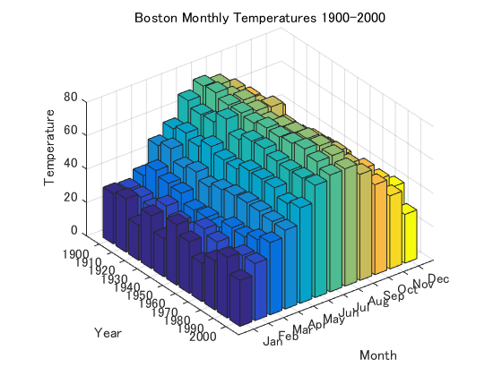
Figure 1: a matlab diagram.

3-2) Literature Review

Here you can write a concise literature review covering all the research related to your research problem. You are advised to use a table representing a brief

3-3) Purpose of the Research

The purpose of the study should be explained here. Answering questions like, why? How important? What if? … may help the student to write a good PoR. Be generous and devote ample space to write these down.

3-4) Research Methodology

Here, the research methodology should be explained in details. This part, may consist of several subsections, depending on the topic and the department policy.

3-5) Research Questions or Hypothesis

This research seeks to answer the following questions:
- How can I improve the patient's flow in the emergency department?
- How can the objectives be: to reduce the patient's expectations, to reduce the amount of carbon dioxide produced by the use of electrical equipment in the patient's flow process?
- How can better improve the patient's flow in the emergency department?

References | 4

